Method:
Setup:
Maximum density was taken to be 1 car per 4.4m per average car length, maximum velocity was taken to be 30mph based off a regular road. Number of cycles taken to be 1 due to limitations of the programming model for multiple cycles. Timings taken from Ella’s data which said average length was 27s and interval was around 43s. Only used car and taxi data as they are average car length, ignored buses and bikes etc. Using data the average flux for a day was taken to be 0.189 cars per second by averaging the hourly count for South bound.
Second light was taken to be around ~200m away from the first to simulate the road from booth too Brunswick Street on upper brook street.
System was modelled with the second shockwave/dissipation wave depending on the rarefaction fan from the first light. The trajectories were then modelled using this.
Using the diffusion and shockwaves for 1 phase of light 1 and light 2 it simulates a realistic system of traffic lights. It uses Eulers method to approximate the car’s trajectory through each section, (used 0.5s jumps due to time and computation required for smaller jumps) adjusting the car’s path according to rarefaction fans from greenlights and the shockwave and dissipation curve from each light. 200 arms were used to simulate the rare fraction fans. OR, Vehicle trajectories were computed using a forward-Euler time-stepping method with timestep $Δt=0.5$s. At each step, trajectory updates were modified by interactions with shockwaves, dissipation curves, and rarefaction fans.
To calculate an average delay time, it measures the theoretical time to travel through without any lights and calculates the average time for 9 cars at 10s intervals to pass through the system. It uses these values to find the delay and then the average delay. A small error occurred due to snapping in the numerical method However, this actually had no overall effect as it was similar for all. Instead, the uncertainty was calculated by determining how much a slight change in entry time affected the car trajectories. This was found by repeating the cars but offsetting the entering time by +2 and +5s. This uncertainty shows how the random entrance of cars affects the average time for each offset. The delays were then plotted and the minimum delay found and subsequently and approximate best offset.
Delay was defined as the difference between the actual travel time through the system and the corresponding free-flow travel time.
The analysis was restricted to a single representative signal cycle. This isolates the primary interaction between the two lights while avoiding additional multi-cycle feedback effects that were not robustly resolved by the current implementation.
Conclusions:
The minimum delay occurs when vehicles released from the first light arrive at the second light during a more favourable phase of its cycle, reducing stopping and queue formation.
Optimal light time is approximately
Shows that with a certain offset the average time decreases but once the lights become staggered the average time actually increases.
Future/expansion:
Could be improved using a more rigorous model due to errors from time jumping/numerical method.
Problems at larger scale due to successive light cycles having potential ripple effects.
My understanding:
When the offset is zero, the two lights are synchronised, so vehicles delayed at the first light often encounter the second light in the same phase, leading to compounded delays.
As the offset increases, vehicle arrivals at the second light become more spread across its signal cycle. This allows some vehicles delayed at the first light to pass the second without stopping, reducing the average delay.
At an optimal offset (~20–25 s), vehicles released from the first light arrive at the second light just as it turns green, minimising stopping while still allowing some free-flow vehicles to pass without being significantly delayed.
For larger offsets, this coordination is lost, and most vehicles are forced to stop at at least one light, increasing the average delay a lot.

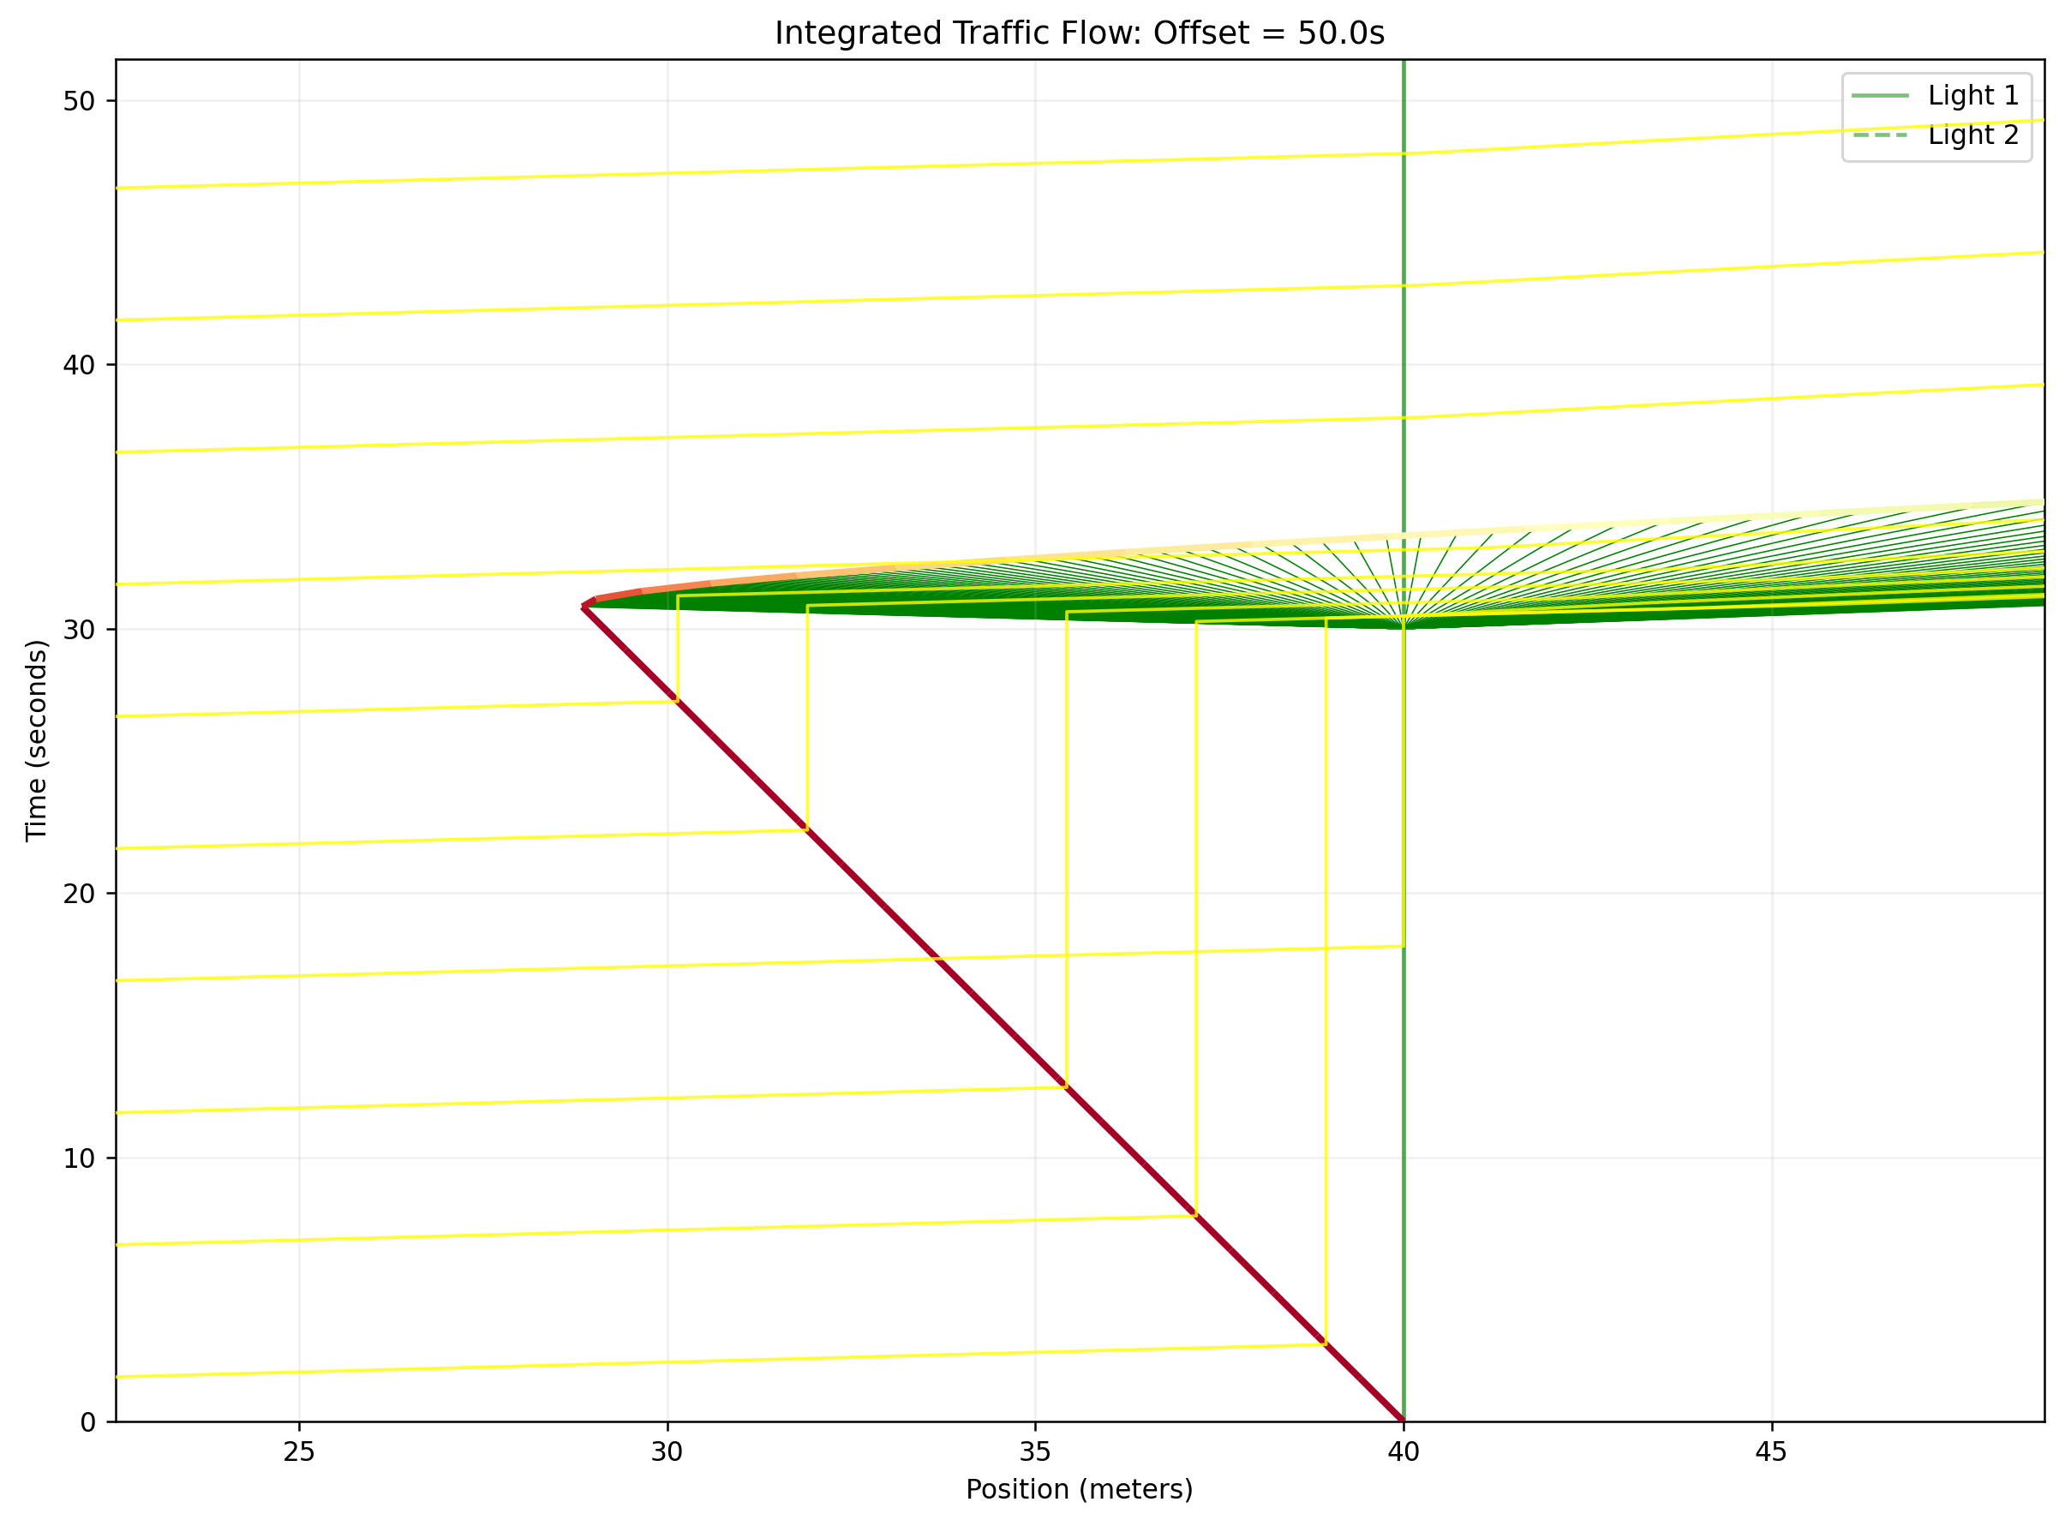
Clipping arises from the finite timestep used in the numerical method, causing small discontinuities when trajectories interact with shockwaves or stopping conditions. This is a systematic effect present in all simulations and therefore does not affect the relative comparison between offsets. Although it introduces small local inaccuracies, the resulting impact on the mean delay is negligible, and the overall trend in delay with offset remains robust.
At larger offsets, the numerical method becomes more sensitive to timestep effects, and small clipping errors can accumulate when trajectories interact with the second light. This can lead to a slight overestimation of delay in the extreme offset regime. However, the overall trend and the location of the minimum delay remain unaffected its just for the larger times that it has a large effect.
It is important to note that this is a numerical simulation, and therefore subject to discretisation effects arising from the timestep method. However, these effects do not significantly impact the overall trend, and the location of the minimum delay remains reasonably accurate.
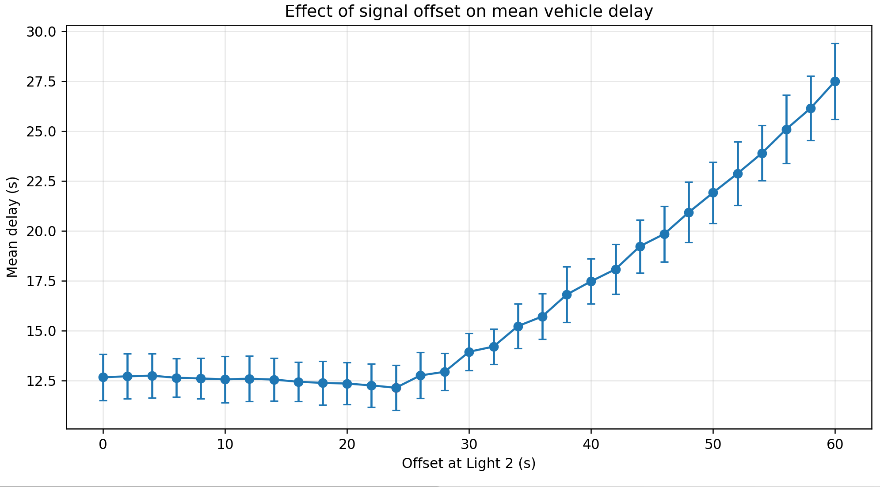
Raw data:
Offset = 0 s | vals = [13.69078747 12.87304334 11.40895796] | Mean delay = 12.66 s | Error = ±1.16 s
Offset = 2 s | vals = [13.70103921 12.93239272 11.48292657] | Mean delay = 12.71 s | Error = ±1.13 s
Offset = 4 s | vals = [13.72563514 12.94644628 11.53980596] | Mean delay = 12.74 s | Error = ±1.11 s
Offset = 6 s | vals = [13.47964801 12.82735102 11.58668618] | Mean delay = 12.63 s | Error = ±0.96 s
Offset = 8 s | vals = [13.54315169 12.71726501 11.53178265] | Mean delay = 12.60 s | Error = ±1.01 s
Offset = 10 s | vals = [13.59062644 12.7745611 11.29325361] | Mean delay = 12.55 s | Error = ±1.16 s
Offset = 12 s | vals = [13.60914741 12.80358012 11.34598483] | Mean delay = 12.59 s | Error = ±1.15 s
Offset = 14 s | vals = [13.4553363 12.8011053 11.36712716] | Mean delay = 12.54 s | Error = ±1.07 s
Offset = 16 s | vals = [13.34408096 12.5633442 11.38780899] | Mean delay = 12.43 s | Error = ±0.98 s
Offset = 18 s | vals = [13.3496867 12.58517307 11.1890754 ] | Mean delay = 12.37 s | Error = ±1.10 s
Offset = 18 s | vals = [13.3496867 12.58517307 11.1890754 ] | Mean delay = 12.37 s | Error = ±1.10 s
Offset = 20 s | vals = [13.22010249 12.62070432 11.18479511] | Mean delay = 12.34 s | Error = ±1.05 s
Offset = 22 s | vals = [13.23358513 12.4202486 11.09017669] | Mean delay = 12.25 s | Error = ±1.08 s
Offset = 24 s | vals = [13.12157383 12.3733012 10.89777184] | Mean delay = 12.13 s | Error = ±1.13 s
Offset = 26 s | vals = [13.76399907 12.97703875 11.49768924] | Mean delay = 12.75 s | Error = ±1.15 s
offset = 28 s | vals = [13.87740827 12.91807749 12.00036788] | Mean delay = 12.93 s | Error = ±0.94 s
Offset = 30 s | vals = [14.6695337 14.24427042 12.8902378 ] | Mean delay = 13.93 s | Error = ±0.93 s
Offset = 32 s | vals = [15.10260884 14.14691103 13.34025626] | Mean delay = 14.20 s | Error = ±0.88 s
Offset = 34 s | vals = [16.30593166 15.28450782 14.07472243] | Mean delay = 15.22 s | Error = ±1.12 s
Offset = 36 s | vals = [16.78384237 15.83163831 14.50768886] | Mean delay = 15.71 s | Error = ±1.14 s
Offset = 38 s | vals = [18.14880964 16.90447656 15.36068781] | Mean delay = 16.80 s | Error = ±1.40 s
Offset = 40 s | vals = [18.50802484 17.6356036 16.26624419] | Mean delay = 17.47 s | Error = ±1.13 s
Offset = 42 s | vals = [19.24496372 18.2298663 16.75761639] | Mean delay = 18.08 s | Error = ±1.25 s
Offset = 44 s | vals = [20.50502548 19.32195249 17.85329476] | Mean delay = 19.23 s | Error = ±1.33 s
Offset = 46 s | vals = [21.13630976 20.03269006 18.3714197 ] | Mean delay = 19.85 s | Error = ±1.39 s
Offset = 48 s | vals = [22.39042513 21.03151338 19.3613176 ] | Mean delay = 20.93 s | Error = ±1.52 s
Offset = 50 s | vals = [23.31788376 22.15458385 20.27448572] | Mean delay = 21.92 s | Error = ±1.54 s
Offset = 52 s | vals = [24.407191 22.98238077 21.23683276] | Mean delay = 22.88 s | Error = ±1.59 s
Offset = 54 s | vals = [25.13976923 24.14295643 22.40613212] | Mean delay = 23.90 s | Error = ±1.38 s
Offset = 56 s | vals = [26.77695238 25.18396142 23.33956162] | Mean delay = 25.10 s | Error = ±1.72 s
Offset = 58 s | vals = [27.67957407 26.31333338 24.47187696] | Mean delay = 26.15 s | Error = ±1.61 s
Offset = 60 s | vals = [29.30745586 27.68920008 25.51831088] | Mean delay = 27.50 s | Error = ±1.90 s
Minimum ≈ 24 s

